MATHEMATICS METHODS

MAWA Semester 1 (Unit 1) Examination 2015

Calculator-free

Marking Key

Section One: Calculator-free (60 Marks)

Question 1(a)
Solution
Marking key/mathematical behaviours | Marks
- Determines | 1

Question 1(b)
Solution
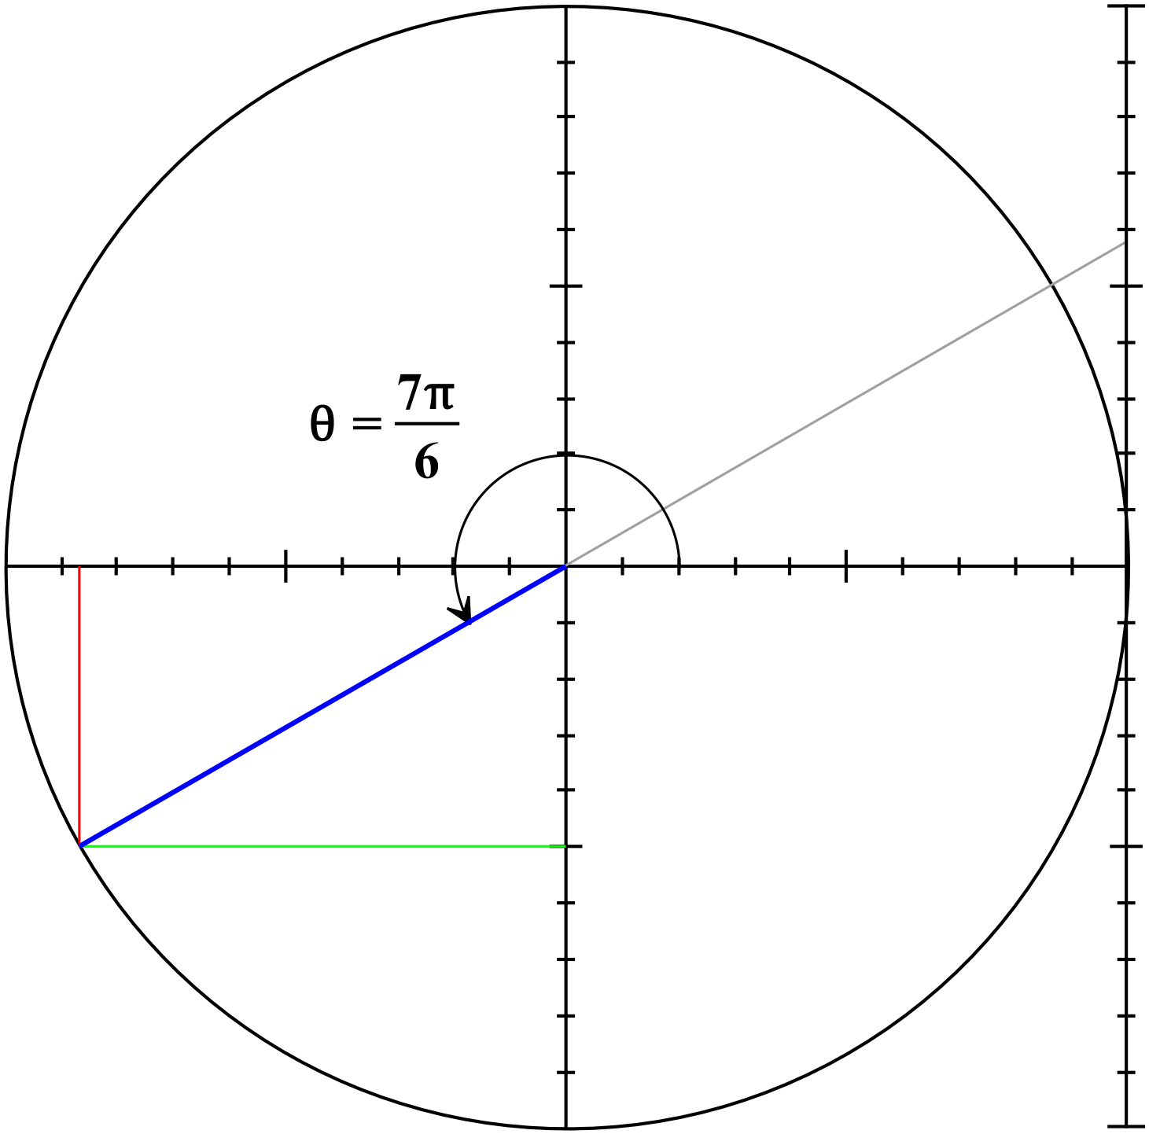

by using the right triangle identity or
by knowledge of exact values
Similarly
Marking key/mathematical behaviours | Marks
- indicates use of or uses meaningfully  - states correct exact value of (accept )  - indicates use of  - states correct exact value of (accept ) | 1  1  1  1

Question 1(c)
Solution
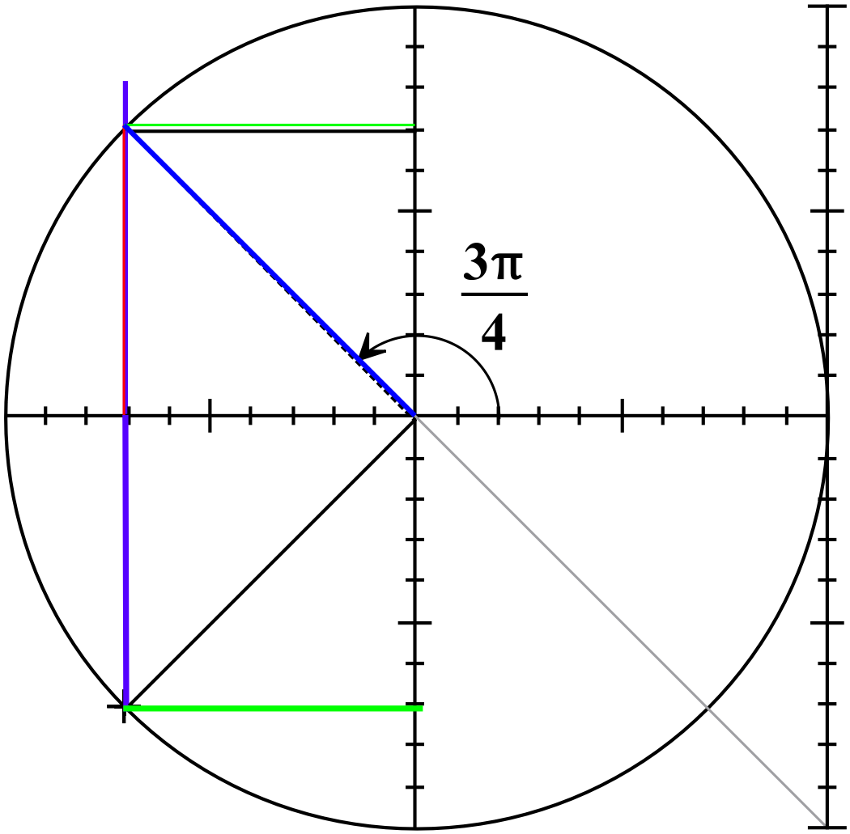
From exact values and use of unit circle,
Marking key/mathematical behaviours | Marks
- indicates method of determination on diagram  - states both correct values of | 1  1

Question 2(a)
Solution
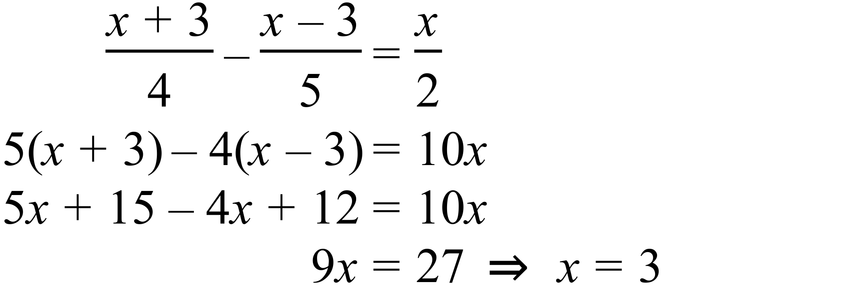

Marking key/mathematical behaviours | Marks
- multiplies the equation by the LCD  - expands brackets and simplifies  - solves for x | 1  1  1

Question 2(b)
Solution
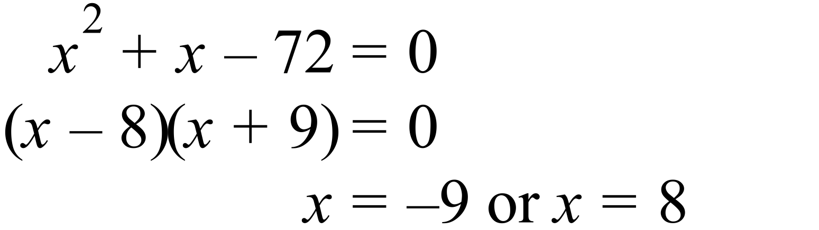

Marking key/mathematical behaviours | Marks
- factorises trinomial  - solves for x | 1  1

Question 2(c)
Solution
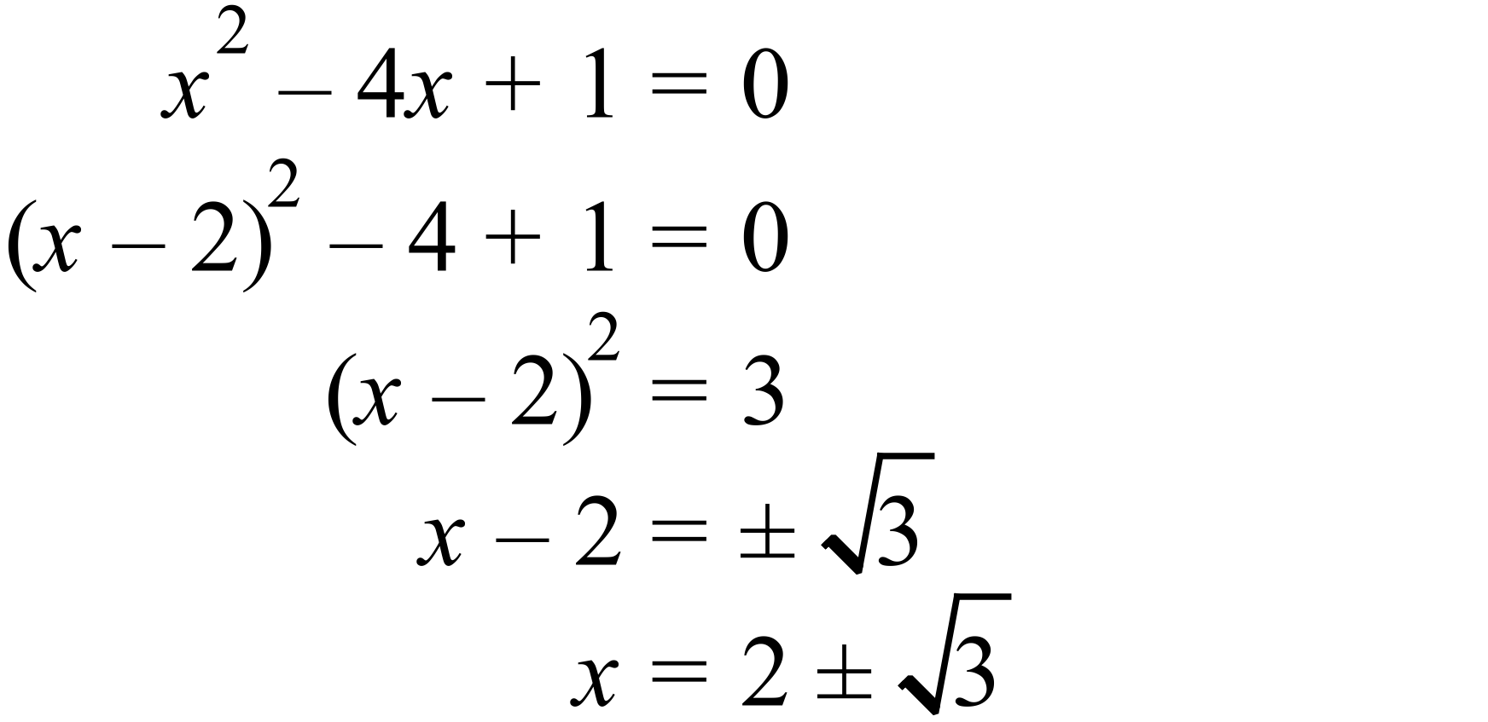
Marking key/mathematical behaviours | Marks
- completes the square  - equates 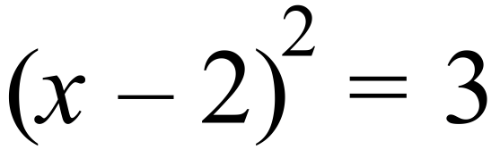  - takes square root  - solves for x | 1  1  1  1

Question 3
Solution
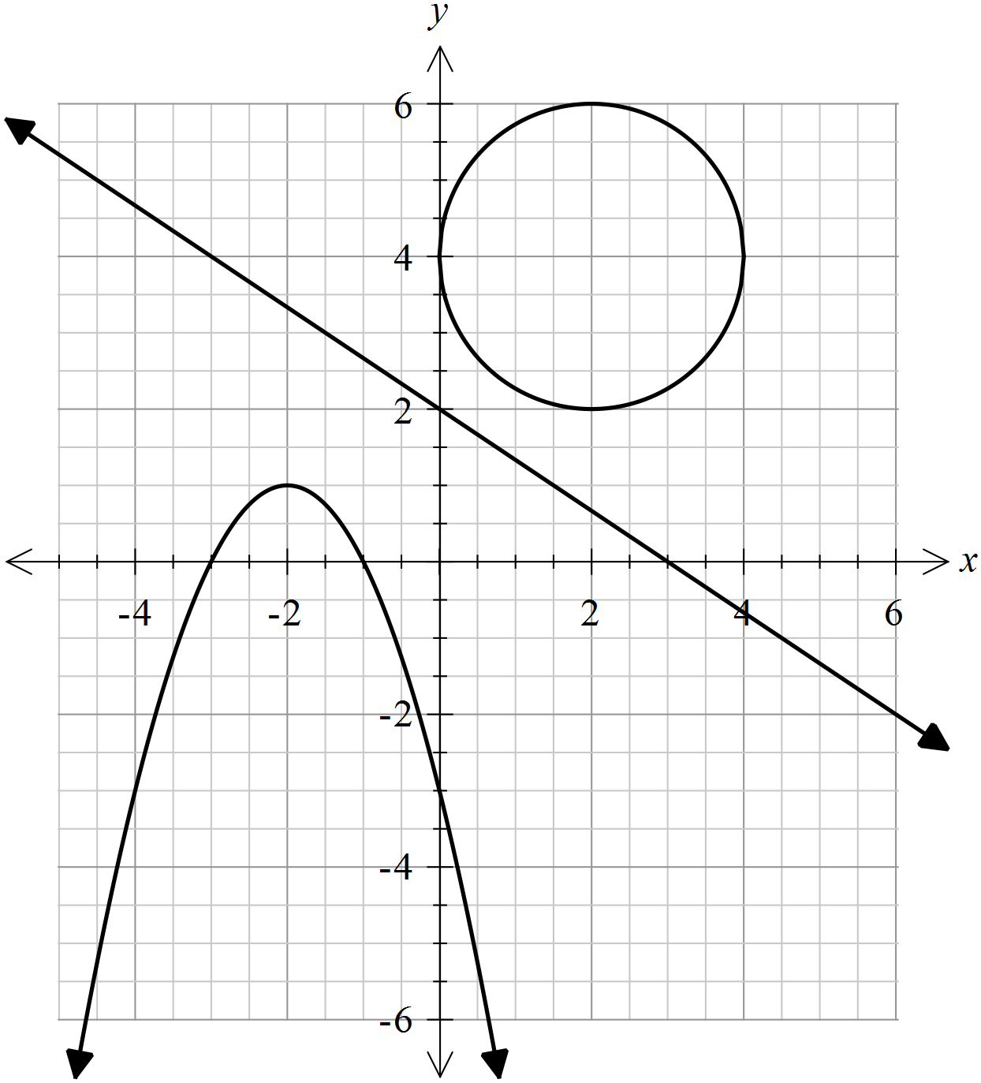

Marking key/mathematical behaviours | Marks
- sketches 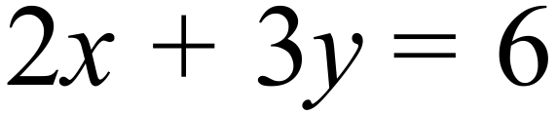 accurately, showing x and y intercepts  - sketches 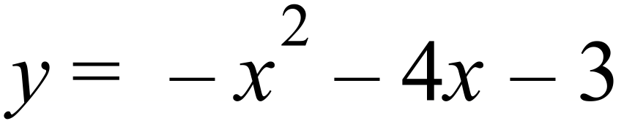reflecting the correct turning point, orientation and intercepts  - sketches 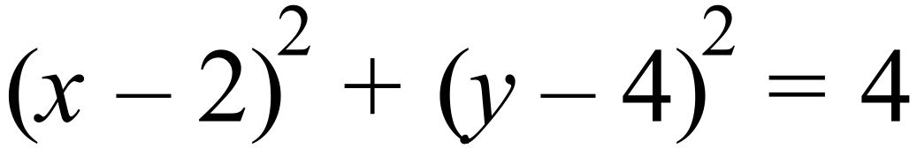 with correct radius and centre | 1+1  1+1+1  2

Question 4
Solution
Graph A:
Graph B: 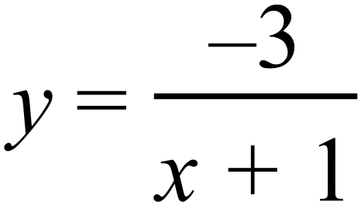

Marking key/mathematical behaviours | Marks
- Graph A  - correct horizontal translation  - recognition of reflection in  - Graph B  - correct horizontal translation  - correct dilation factor  - recognition of reflection in | 1  1  1  1  1

Question 5(a)
Solution
- From part (i), P(X) = 0.7 and P(Y)= 0.5
P(X) P(Y) = 0.35 0.3
Therefore not equal
Marking key/mathematical behaviours | Marks
(i)  - determines  - determines correct value for  (ii)  - determines  - shows that | 1  1  1  2

Question 5(b)
Solution
Marking key/mathematical behaviours | Marks
(i)  - applies the conditional probability formula  - substitutes correctly  - multiplies correctly and simplifies  - determines correct value for  (ii)  - determines  - applies complimentary property and arrives at the correct result | 1  1  1  1  1  1

Question 6(a)
Solution
Has the form
Period = hence =
Vertical translation 1 unit up, hence = 1.
Dilation parallel to y axis, scale factor = 3. Hence, a = 3

Marking key/mathematical behaviours | Marks
- determines the period and hence  - identifies vertical translation and determines = 1  - determines  - states the correct equation | 1  1  1  1

Question 6(b)
Solution
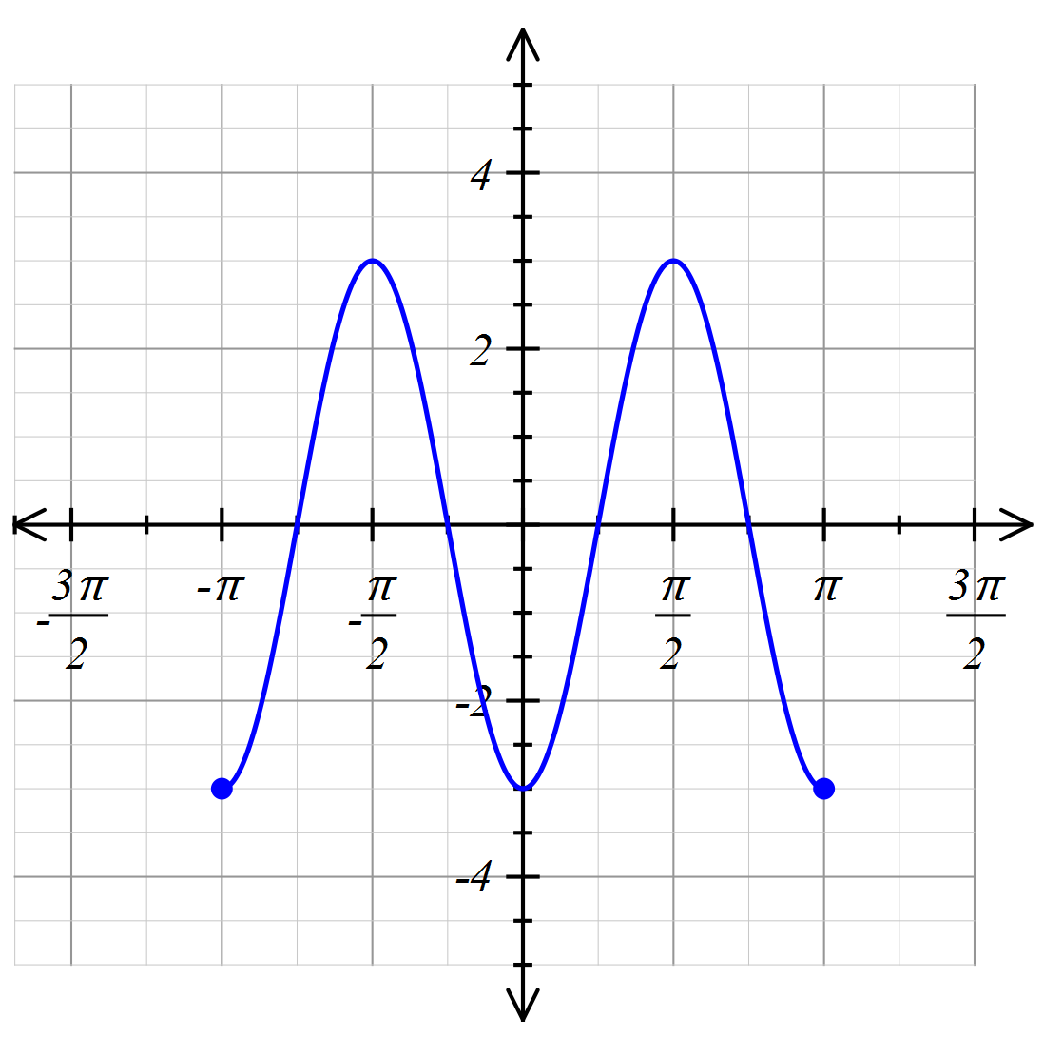

Marking key/mathematical behaviours | Marks
- graph is drawn over the correct domain  - graph is a cosine curve with the correct amplitude  - graph has the correct period  - phase shift is correct  - graph is accurate passing through (0,-3) and has smooth turning points | 1  1  1  1  1

Question 7 (a)

one mark denominator one mark numerator of answer
Question 7(b)

one mark for two products, one mark denominator one mark numerator of answer

Question 7(c)
one mark for two products, one mark denominator one mark numerator for answer

Question 7(d)

2 marks for denominator, one mark for numerator, one mark for final answer

Marking key/mathematical behaviours | Marks
(i)  - states correct sample space  (ii)  - determines that there are 6 pairs of numbers (listing or logic) that have an even product and determines the correct probability of an even product  (iii)  - indicates that the only way that the product can be prime is if one of the cards has a one on it.  - determines the correct probability of a prime product  (iv)  - provides some form of exhaustive listing of the sum of two numbers  - determines that there are only 4 possibilities of prime sums  - determines the correct probability of the sum being prime | 1  1+1  1  1  1  1  1

